**LAB TASK 7:  
NAME: JAWAD AHMED**

**ROLL : K240678**

Q1:  
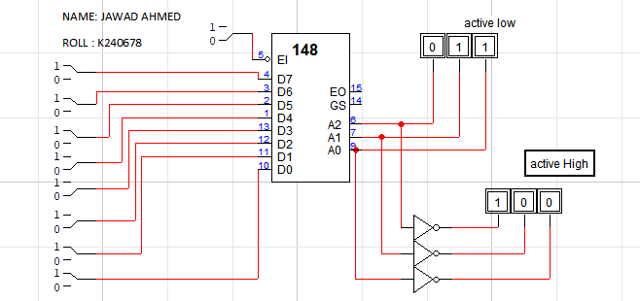

Q2:

